Session 7

Task 1
Create a table called Restaurant with columns: id, name, location, and cuisine. Apply NOT NULL constraint to name and location, and make id the PRIMARY KEY.
Query
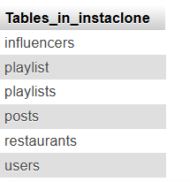
Task 2
Create a table called FoodOrder with columns: order_id, restaurant_id, user_id, and order_total. Set order_id as PRIMARY KEY, and add a FOREIGN KEY constraint on restaurant_id referencing Restaurant(id).
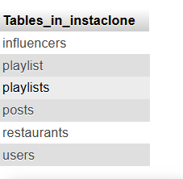
Task 3
Insert 6 rows into a table called SpotifyUser with columns: user_id, username, email, and subscription_type. Ensure that username is UNIQUE and email is NOT NULL.<br><br><em><strong>Hint:</strong> Use the UNIQUE and NOT NULL constraints when creating the table.</em>
Query
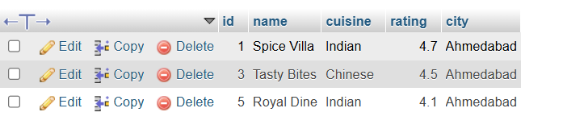
Task 4
Create a VIEW named TopSpendersView that shows usernames and order_total from a FoodOrder table where order_total is greater than 1000.
Query
QUERY:
CREATE VIEW TopSpendersView AS
SELECT
SpotifyUser.username,
FoodOrder.order_total
FROM FoodOrder
INNER JOIN SpotifyUser
ON FoodOrder.user_id = SpotifyUser.user_id
WHERE FoodOrder.order_total > 1000;

Output:
yasmin | order_total
saniya | 2500.00
sana | 1800.00
Arzoo | 3000.00
aashiya | 1200.00
Saleha | 3400.00
5.Write a SQL query to list all users from the TopSpendersView who have spent more than 2000, sorted by order_total descending.<br><br><em><strong>Constraint:</strong> Only use the TopSpendersView for your query, not the original FoodOrder table.</em>
QUERY:
SELECT username, order_total
FROM TopSpendersView
WHERE order_total > 2000
ORDER BY order_total DESC;
Output:
Username | order_total
Yasmin25 | 3000.00
Saniya55 | 2500.00

